
OpenEdge Memory Profiler Workshop Solutions
Hâvard Danielsen
Senior Principal Consultant
Professional Services US



Contents
OpenEdge Memory Profiler Workshop Solutions 1
Read Data Test 2
Dataset dsTimeSheet 3
Dynamic Query 4
Large Objects 6
Update Data Test 7
Business.ItemBE and BusinessOrderBE 7
Update Data Test after fix of class leaks 9
Fix memptr leaks in the timezone utility 9
MEMPTR number 1 9
MEMPTR number 2 9
MEMPTR number 3 10
Background 10
Fixes 10
Update Data Test 11
One Run 11
Eliminate cross reference in ItemBE 14
Problem 14
Background 14
Solution 15
One Run (after eliminating the class leak) 16
Fix dataset leak in InvoiceBE 18
Problem 18
Solution 18
Fix temp-table leak in SupplierBE 18
Problem 18
Solution 18
Fix temp-table leak in Framework 19
Problem 19
Background 19
Solution 19
Fix more memptr leaks in the timezone utility 19

Memory Profiler Workshop Solutions
This document discusses how to find and fix memory leaks in the application used for the Memory Profiler Workshop. The solutions follow the suggested order of the REST tests.

Read Data Test
The following section discusses memory leaks that can be seen by running the Read data collection from the REST test tool (Postman or Bruno).
The _PreCleanup tag shown in screen shots will have all leaks in Progress memory after the Pas instance is stopped. Since this snapshot is taken before the cleanup it is a quick way to see memory leaks that would exist between PAS requests. You can find these also in the _EndOfRequest tag snapshots while PAS is running for example by comparing these before and after bumps in the chart or by looking at the last one.

Dataset dsTimeSheet
ABL Types – Dataset – dsTimeSheet - multiple entries shown

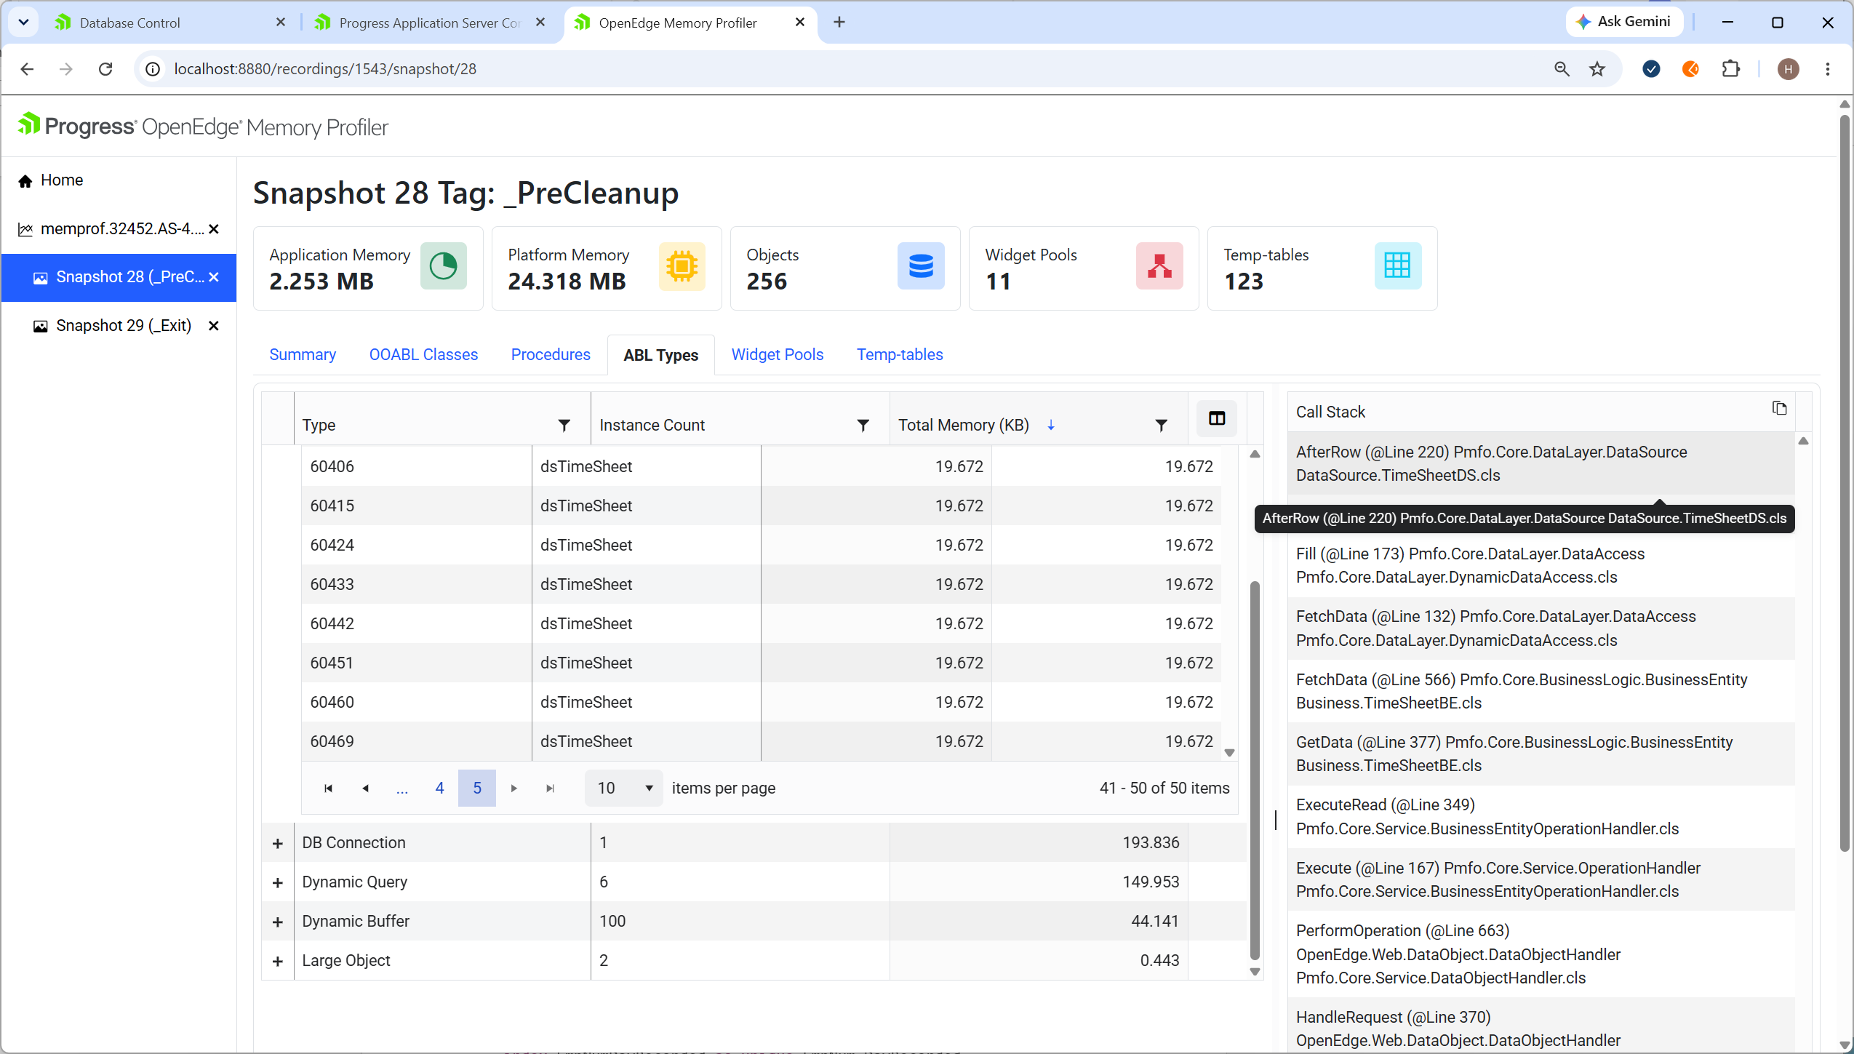
Can also be seen in
- ABL Types - Dynamic Buffer – ttTimeSheet
- Temp-Tables – Auto Dynamic Temp-table – ttTimeSheet
The bi* buffers and temp-tables show the before image buffer and table for the corresponding tt* and there is no need to look at both the bi* and the tt*. This knowledge is based on the naming convention used.

Problem
TimeSheetDS AfterRow calls super:AfterRow and passes the dataset phDataset as a deep copy.

Line 168
super:AfterRow(input dataset-handle phDataset).

Background
TimeSheetDS inherits from the abstract DataSource.

class DataSource.TimeSheetDS inherits DataSource:
The abstract DataSource has an AfterRow method that populates a field that tracks the read order. This field is defined in almost all temp-tables for the sole purpose of ensuring that dataset write-json serializes rows in the order they are read. This is done to work around the fact that write-json serialization is using the primary index.
See snippet from schema/timesheet.i below that defines a zz_seq field as hidden and defines a primary index with the field. (The framework has logic to use the first unique index as the main identifier.) This pattern can be seen in most of the temp-table definitions.

field zz_seq as int64 serialize-hidden
index EmpNumDayRecorded as unique EmpNum DayRecorded
index zz_seq as primary zz_seq

TimeSheetDS has a PrepareBuffer override that sets AfterRow as callback for the dataset.after-row-fill event. The PrepareBuffer is called by the DataSource when preparing for fill of the dataset. It is implemented as an override in each concrete DataSource class to make it easy to control which dataset event to use and the bind of the temp-table.

method override protected void PrepareBuffer( input pBuffer as handle ):
define variable hTable as handle no-undo.
pBuffer:set-callback("After-Row-fill","AfterRow").
hTable = pBuffer:table-handle.
this-object:Bind (table-handle hTable bind).
end method.
Classes that need additional logic to populate other fields for each row will have an AfterRow override as in this case.
The TimeSheetDS defines the AfterRow override to convert the timesheet table fields that stores time in and in separate fields for AM and PM to TimeIn and TImeOut datetime fields defined in the temp-table schema.
The call to super:AfterRow is intended to ensure that the logic topopulate the zz_seq field is invoked. When this is done without passing the dataset by-reference a dynamic dataset copy will be created for each row and never be deleted. The population of the zz_seq field will be applied to the copy and not be assigned to the intended table in the dataset that is returned to the client.

Solution
Pass the dataset to super:AfterRow by-reference

super:AfterRow(input dataset-handle phDataset by-reference).

Notes
This leak will also show up in the Update collection test until it is fixed, since the AfterRow method is called also as part of the refresh of data after an update.

All dataset events have a dataset as input parameter. This allows the event method to use static code to access the dataset if the event is defining the parameter as dataset and not dataset-handle. In this framework the dataset is not defined in the data layer. The temp-tables can still be accessed with static code since the table is passed to the Bind method defined for the table.

Dynamic Query
ABL Types – Dynamic Query – Dynamic Query – There are multiple entries that all has the same call stack. There are 6 instances for each run of the Read collection.

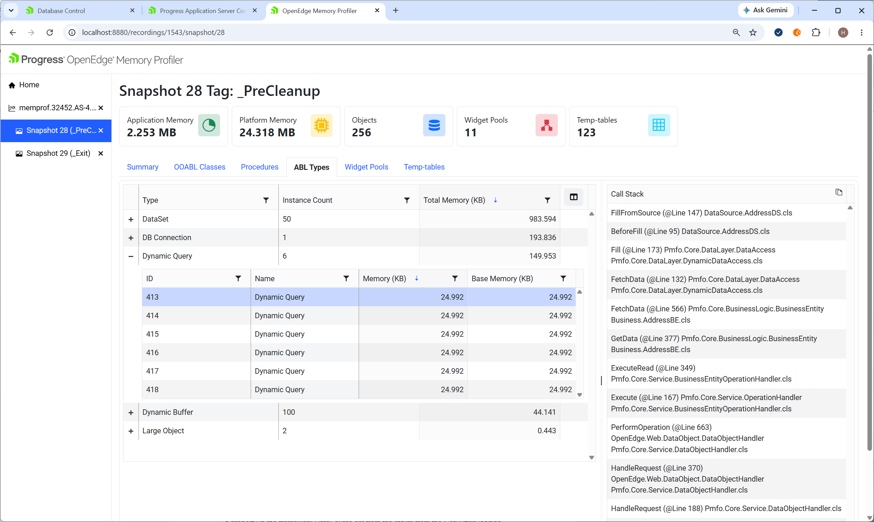

Problem
AddressDS FillFromSource creates a query in a local variable. The creation is not the problem, dynamic queries are necessary in modern code. However, the query is a handle and is not garbage collected and will remain in memory if it is not deleted.

Background
This AddressDS is populating the ttAddress temp-table defined in AddressBE to expose a public “addresses” resource to the UI. There is currently no address table in the database. so the data is populated by defining the before-fill call-back on the dataset to call a BeforeFill method.

method override protected void PrepareBuffer( input pBuffer as handle ):
define variable hTable as handle no-undo.
pBuffer:set-callback("before-fill","BeforeFill").
hTable = pBuffer:table-handle.
this-object:Bind (table-handle hTable bind).
end method.

The before-fill event is called only once from the dataset:fill method and allows full control of the population of temp-table records and will typically have code to create all records and fields and a return no-apply to avoid creating any record.
In this case AddressDS BeforeFill is used to populate the ttAddress temp-table from 6 different database tables. This is why there are 6 leaks per run.

Solution
Delete the query handle at the end of the AddressDS fillFromSource method. Do this in a finally block to ensure the query also is deleted in case of an unexpected error during the query processing.
Dynamic queries are resolved at runtime and are thus quite prone to errors. In this case there could also be errors when a temp-table record is created from the database table record.

finally:
if valid-handle(hQuery) then
delete object hQuery.
end.

Notes
It is possible to use widget-pools in a way that scopes the handle creation to the widget-pool and is cleaned up when the widget-pool is deleted.

Large Objects
ABL Types – Large Objects – Large Object
There are 2 Large Object entries after running the Read Collection. The number of entries remains the same after multiple runs. The Call Stack shows that both leaks origin in Pmfo.Util.TimeZoneUtil, but in different methods.

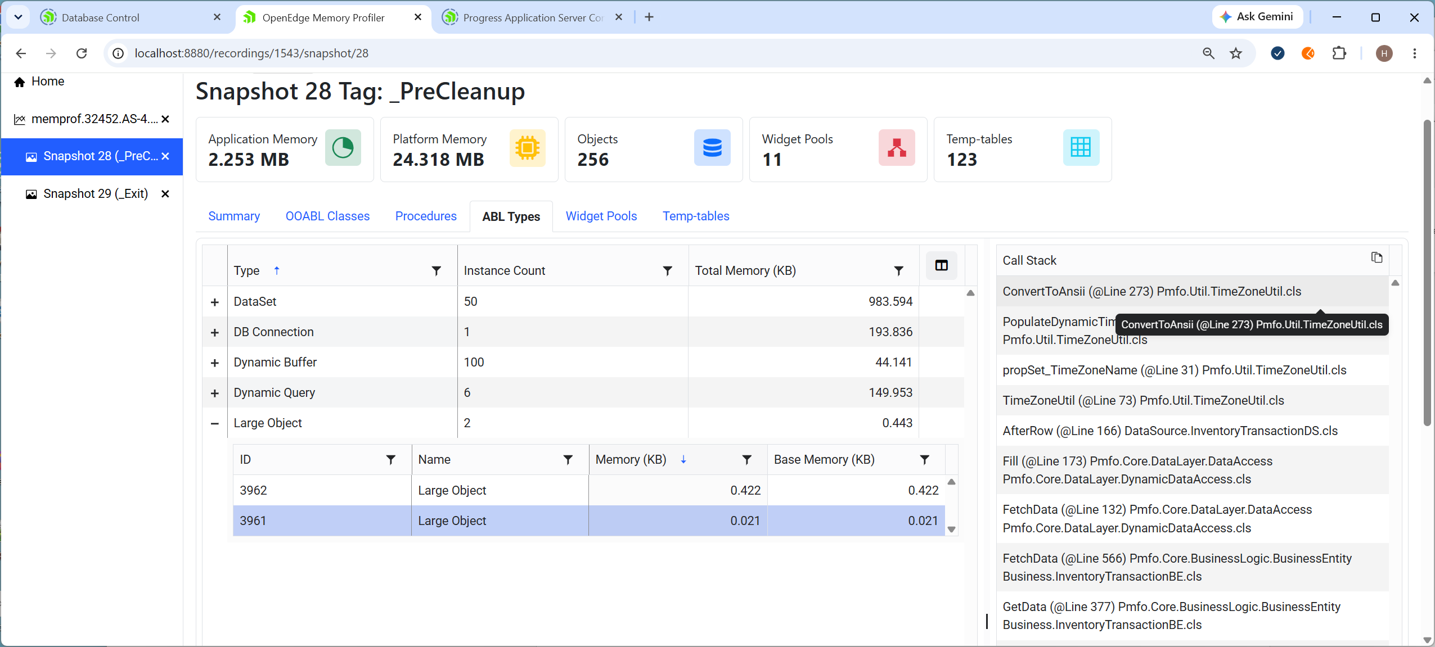

Problem
The first entry shows the DynamicTimeZoneInformation property setter (propSet_DynamicTimeZoneInformation) at the top of the call stack.
The code reveals that this is a MEMPTR and that it is a static property and thus expected to stay in memory while PAS is running. The fact that this is static introduces a problem since there is no easy way to get rid of it when Progress shuts down. This is discussed and resolved in a separate section below.
The second entry shows a memptr created in Pmfo.Util.TimeZoneUtil ConvertToAnsii line 273. Looking at the code shows that this is a local variable and that the size is not set back to 0 again.

Background
The background for the use of memptr in the TimeZoneUtil is discussed below.

Solution
Set size to 0 at the end of ConvertToAnsii. Use a finally block to make sure this is done also if an error occurs in the processing.

finally:
set-size(mTargetAnsi) = 0.
end.

Notes
The WideCharToMultiByte external procedure is called twice from ConvertToAnsii, The purpose of the first call is to get the size needed for the actual conversion in the second call. In the Windows API the mTargetAnsi can be passed as a null pointer. In 32 bit Progress this parameter would be defined as LONG and accept an INTEGER with value 0 from ABL. But in 64 bit Progress LONG variables that were used for to pass 32 bit pointers must be changed to MEMPTR.ABL will throw an error if an uninitialized ABL MEMPTR is passed to an external procedure. This is worked around by setting the size to 1 before the first call and then setting it to the size returned from the first call before the second call. The size is also set to 0 to reset it from the 1 before setting the actual size.

Update Data Test
The following section discusses memory leaks that can be seen by running the Update data collection from the REST test tool (Postman or Bruno). The screen shots is taken after applying the fixes in the previous section.
The _PreCleanup tag shown in screen shots will have all leaks in Progress memory after the Pas instance is stopped.

Business.ItemBE and BusinessOrderBE
The OEABL Classes tab shows that several concrete application classes in memory. The concrete application classes can be identified by the package name being Business or DataSource in memory. These should typically not be in memory in a _PreCleanup snapshot or after a request or in an _EndOfRequest tag snapshot. (The only exception in this application would be the Business.ResourceBE class, which is a meta data business entity used by the ServiceManager to request data about the resources. This should only be in memory if the SessionManager is configured to check for new resources. See readme.md in the github repository for details.
One should always check the OEABL Classes tab and Procedures tab for leaks first. If there are procedure or class leaks, then these should be addressed and resolved first. The other tabs will show all objects owned by classes or procedures that would not have been if those were not leaking. It is theoretically possible to identify those by looking at the Call Stack, but there could also be other classes or procedures in memory owned by leaking classes and procedures.
This application does not explicitly delete OEABL classes, a leak indicates that some classes have cross references that prevent garbage collection. A class leak could originate in any class, but Business Entities are the first objects that are started to handle a request so in this case the cause of leak is likely found on one of these. In this case there will be two instances of each of these for every run of the Update Collection since the test runs one POST request and one DELETE request and both of these will leak,

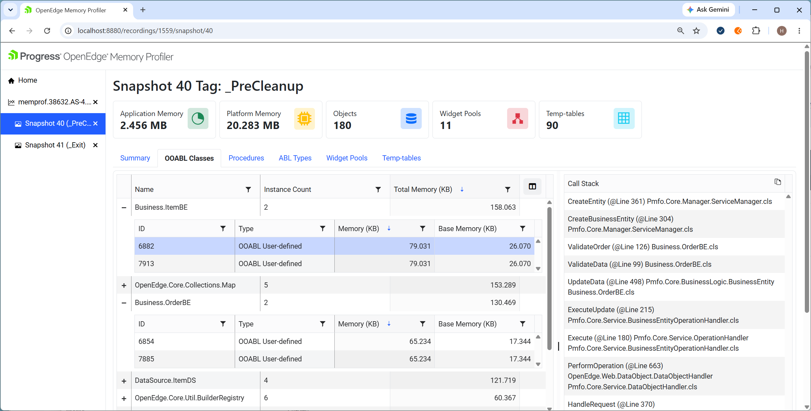

Problem
The Call Stack of ItemBE shows that it is called from OrderBE. OrderBE ValidateOrder starts ItemBE and passes itself as parameter to ItemBE ValidateAndUpdateInventory.

ItemBE = cast(ServiceManager:CreateBusinessEntity('items'),ItemBE).
ItemBe:ValidateAndUpdateInventory(this-object,table ttOrderLine by-reference).

ItemBE ValidateAndUpdateInventory stores the parameter in an Owner property that is used in GetItemInventoryDataForSubmit() to check if an inventory change done in ValidateAndUpdateInventory that reduced item inventory under the threshold should create a ProcessOrder.

The ItemBE:GetItemInventoryDataForSubmit() is called from OrderBE SubmitData to ensure item changes and potential new PrucahseOrders are submitted together with the Order changes, so that the DataAccess will save all changes in one transaction.

The reason for the check is that there is also a ValidateAndUpdateInventory method that adjusts item inventory for PurchaseOrderBE and since these methods support both delete and update the intent is to only trigger creation of PurchaseOrders when the cause of the inventory change is caused by Order changes and not when inventory is changed from PurchaseOrder.
The ItemBE Owner property referencing the OrderBE constitutes a cross reference that prevents both from being garbage collected.

Background
Inventory management is complicated and this example is not very realistic.but it is based on the database write trigger in the Progress install for sports2020. These triggers are disabled by empty trigger code in this application, so this is the replacement The trigger code did not check the caller and could thus create a purchaseOrder if the inventory was reduced by a processOrder deletion or update to a lower qty, so the use of the Owner property kind of makes sense. (Note that we do not ship code that updates sports2020).
The code example shows an OERA implementation that also ensures that all changes in Orders, Items and PurchaseOrders are submitted in a single transaction. This is based on the requirement implied by the trigger and extended to also support delete. Note that the database trigger only creates purchaseOrders when Item is changed, but it is viable that the Item inventory would be changed in a transaction that updates order line or purchase order qty.

Solution
Delete the ItemBE at the end of SubmitData in the finally block that already is there. This is safe since the item data already has been submitted and the data returned to the client only returns order and order lines.

finally:
/* Delete the hdataset if it is dynamic and was created for server only
Do not delete if hdataset equals phdataset and is dynamci since it is
needed for serialization to client */
if valid-object(hDataset) and hDataset <> phDataset and hDataset:dynamic then
delete object hDataset.

// must delete - has cross reference -ValidateOrder call to ValidateAndUpdateInventory
// TODO: Fix ItemBE to not have cross reference - very likely anti-pattern
if valid-object(ItemBE) then
delete object ItemBE.
end finally.

Update Data Test after fix of class leaks
The following section discusses memory leaks that can be seen by running the Update data collection from the REST test tool (Postman or Bruno) after PAS has been restarted with the fix to eliminate the class leak discussed it the previous section.

Dataset dsSalesRep and dsState
ABL Types – Dataset - dsSalesRep
ABL Types – Dataset - dsState
These two datasets both show FetchData CustomerBE as the second entry in CallStack

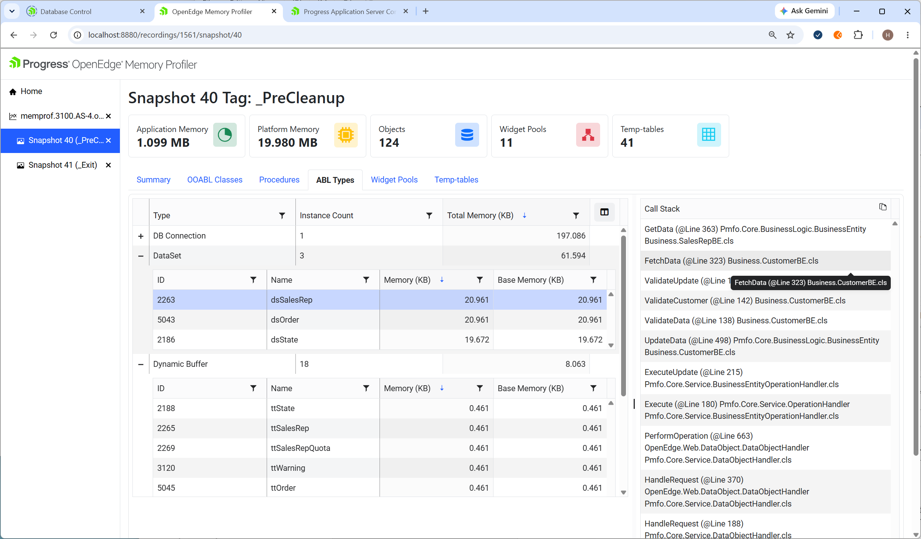
Can also be seen in
Can also be seen in
- ABL Types - Dynamic Buffer – ttState
- ABL Types - Dynamic Buffer – ttSalesRep
- ABL Types - Dynamic Buffer – ttSalesRepQuota
These can also be seen under Temp-Tables – Auto Dynamic Temp-table
The bi* buffers and temp-tables show the before image buffer and table for the corresponding tt* and there is no need to look at both the bi* and the tt*. This knowledge is based on the naming convention used.

Problem
The CustomerBE has the include references that define ttSate and ttSalesRep temp-tables. These temp-tables are owned by the class. (not reference-only)
{schema/salesrep.i}
{schema/state.i}

CustomerBE ValidateUpdate calls FetchData twice with output of table ttState and table ttSalesrep.also as deep copy. The copy to the static temp-tables will not cause a leak since these temp-table will be deleted when the CustomerBE.
CustomerBE FetchData starts a BusinessEntity and calls GetData with the output dataset as a deep copy. The fact that the dataset is not deleted causes a leak.

method protected void FetchData(pcService as character, output table-handle phTable):
define variable oBE as IBusinessEntity no-undo.
define variable hDataset as handle no-undo.
oBE = ServiceManager:CreateBusinessEntity(pcService).
oBe:GetData(output dataset-handle hDataset).
phTable = DatasetUtil:GetBufferByTableSerializeName(hDataset, pcService):table- handle.
end method.

Background
The CustomerBE defines tttSate and ttSalesRep as its own in order to have all records available for validate that the customer state and salesrep has matching Regions.
The deep copy to these temp-tables is necessary since the BusinessEntity used to get the data in FetchData is garbage collected when the method ends (oBe variable goes out of scope) after which the temp-table in the BusinessEntoty nolonger exists.

Solution
Fix FetchData to Get the dataset by-reference to avoid the unnecessary deep copy.

oBe:GetData(output dataset-handle hDataset by-reference).

Notes
The ttSalesRepQuota that is shown in the Memory Profiler is defined in the SalesRepBE dataset and I not in use in this code.

Dataset dsOrder
ABL Types – Dataset - dsOrder
This datasets shows ValidateInvoice InvoiceBE as the second entry in CallStack.

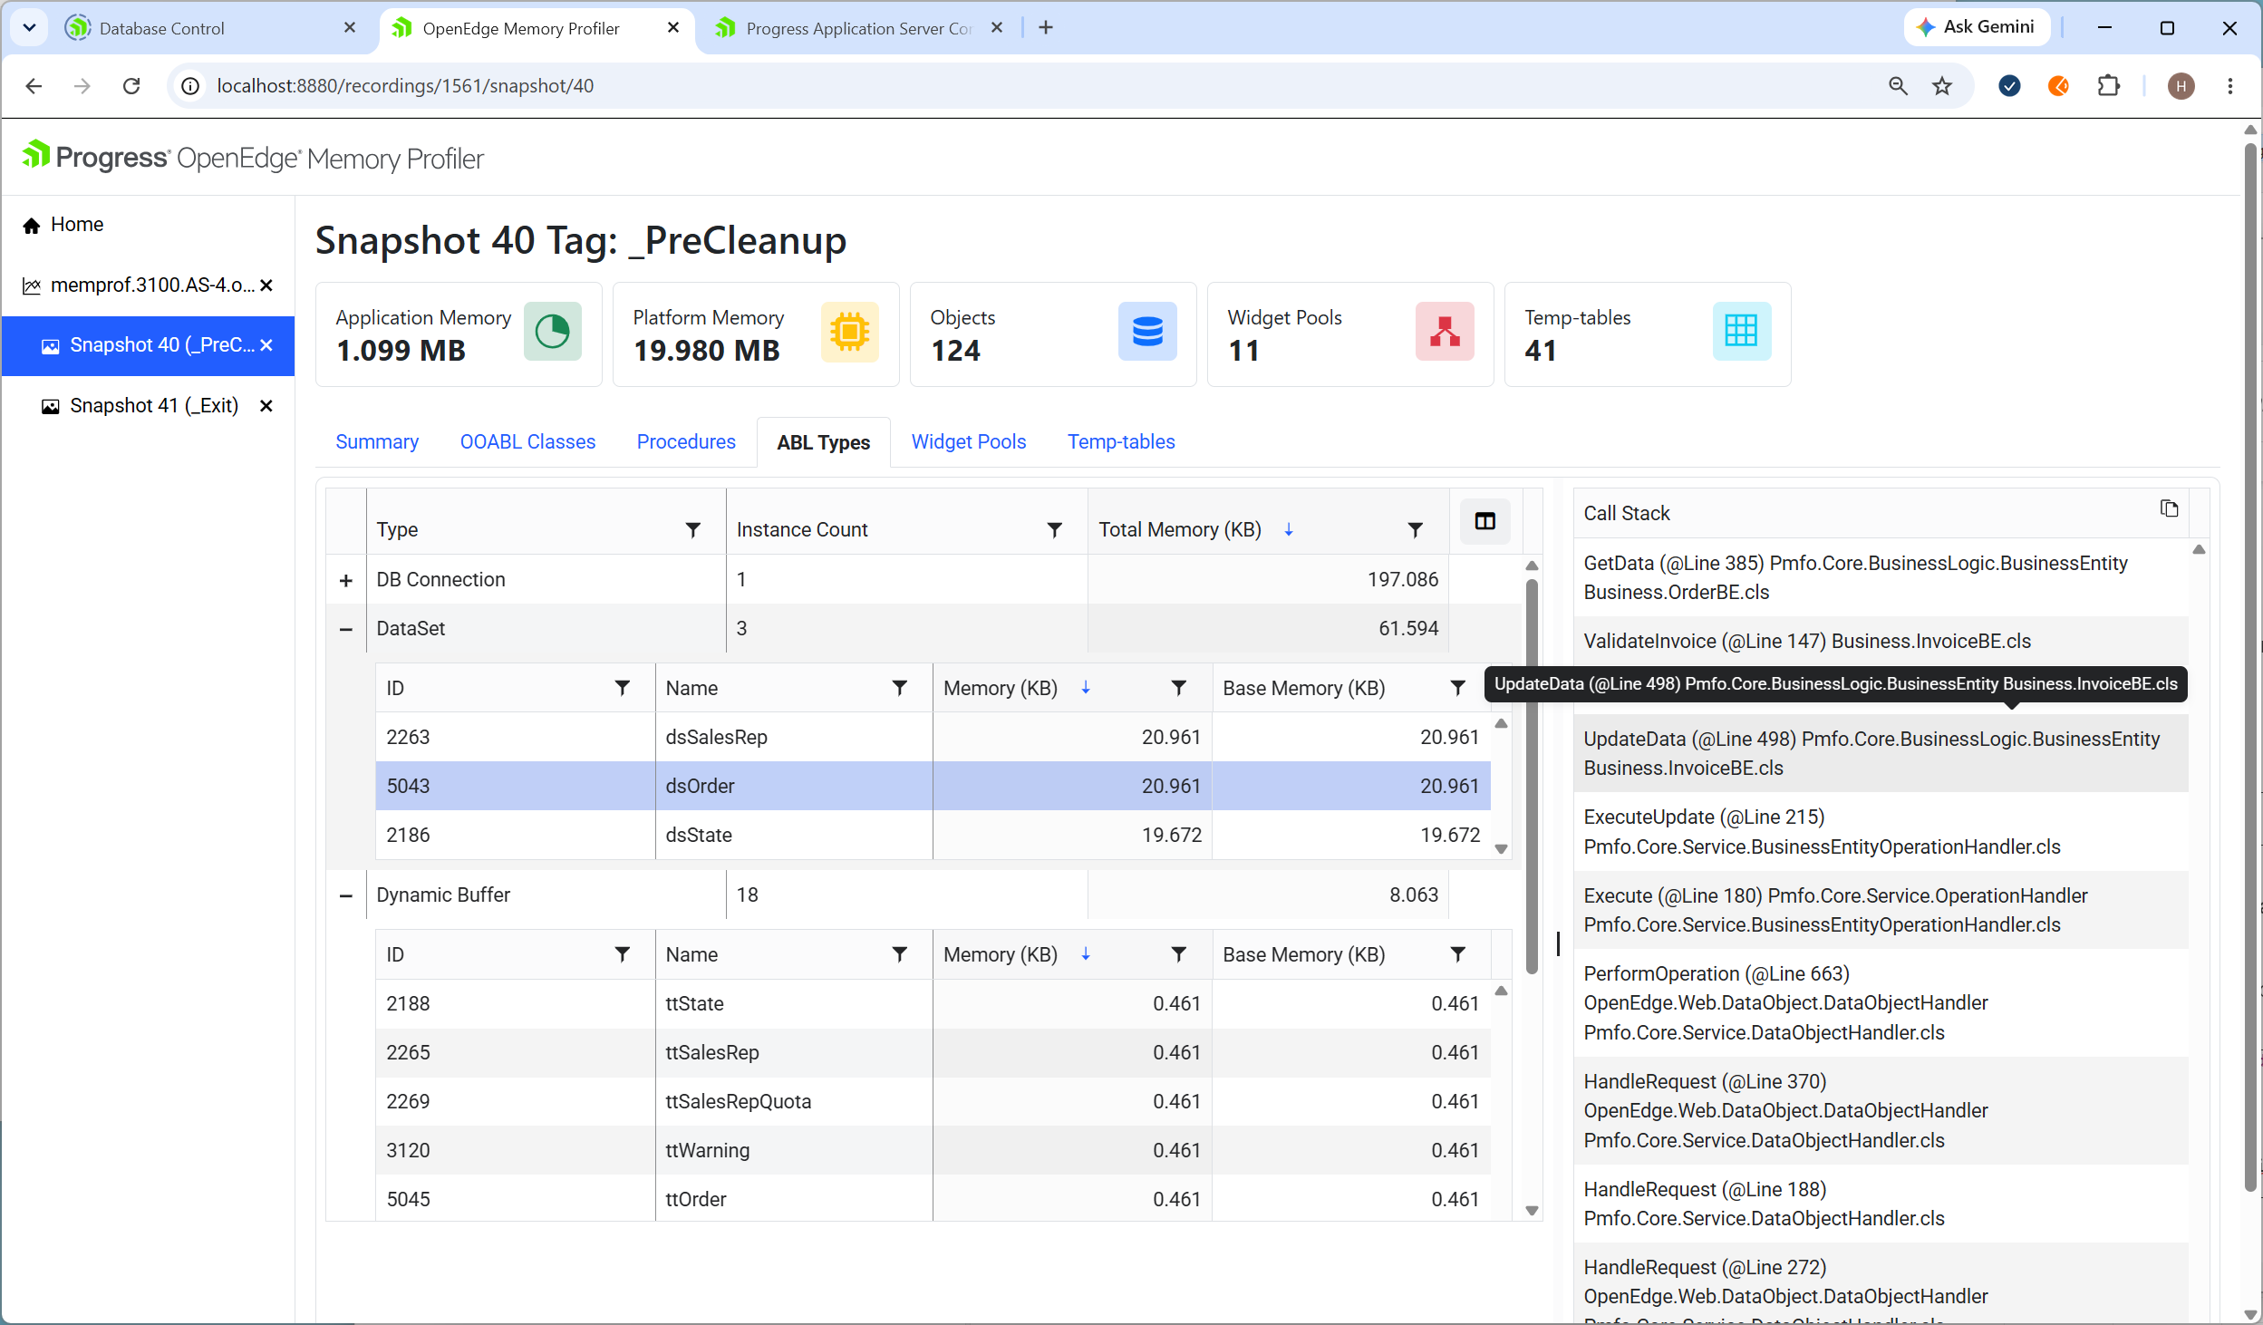
Can also be seen under ABL Types - Dynamic Buffer and Temp-Tables – Auto Dynamic Temp-table. The bi* buffers and temp-tables can be ignored.

Problem
InvoiceBE ValidateInvoice starts OrderBe and calls GetData with the output dataset as a deep copy.
The fact that the dataset is not deleted or called by-reference causes a leak for every ttinvoice record.

The example is edited to fit the Word document
oOrderBE = ServiceManager:CreateBusinessEntity("orders").
oRequest = CreateGetRequest(oOrderBE:datasets[1]).

for each ttInvoice where row-state(ttInvoice) = row-created:
oQueryDefinition = new QueryDefinition().
oQueryDefinition:AddEntry(
new QueryPredicate("OrderNum",
QueryOperatorEnum:Eq,ttInvoice.OrderNum)).

oRequest:TableRequests[1]:QueryDefinition = oQueryDefinition.

oOrderBE:GetData(oRequest, output dataset-handle hDataset by-reference).

hOrderTable = hDataset:get-buffer-handle(1):table-handle.
hOrderLineTable = hDataset:get-buffer-handle(2):table-handle.

UpdateInvoiceFromOrder(buffer ttinvoice,
input table-handle hOrderTable by-reference,
input table-handle hOrderLineTable by-reference).

end.

Solution
Fix ValidateInvoice to Get the dataset by-reference to avoid the unnecessary deep copy. This is safe since the data only is used in the for each block. (The dataset will be replaced each time it is output).

